(b)
Python source code：

import gurobipy as gp
from gurobipy import GRB

# 创建求解primal问题的模型
model = gp.Model("WorkerScheduling")

# 决策变量
x = model.addVars(5, lb=0, vtype=GRB.CONTINUOUS, name="x")
y = model.addVars(5, lb=0, vtype=GRB.CONTINUOUS, name="y")

# 约束条件
model.addConstr(x[0] == 50)
for t in range(2, 6):
model.addConstr(x[t - 1] == 0.95 * x[t - 2] + y[t - 2])

model.addConstr(160 * x[0] - 50 * y[0] >= 6000)
model.addConstr(160 * x[1] - 50 * y[1] >= 7000)
model.addConstr(160 * x[2] - 50 * y[2] >= 8000)
model.addConstr(160 * x[3] - 50 * y[3] >= 9500)
model.addConstr(160 * x[4] - 50 * y[4] >= 11000)

# 目标函数
obj = gp.LinExpr()
for i in range(5):
obj += 2000 * (x[i])
model.setObjective(obj, GRB.MINIMIZE)

# 求解模型
model.optimize()

# 输出结果
if model.status == GRB.OPTIMAL:
print("primal问题最优解:")
for i in range(5):
print(f"month{i}:fulltime_workers = {x[i].x}, month{i}:learning_workers = {y[i].x}")
print(f"目标函数值: {model.objVal}")

else:
print("没有找到primal问题的最优解.")

print("对偶问题最优解：")
print(model.getAttr("Pi",model.getConstrs()))
duel_solution=model.getAttr("Pi",model.getConstrs())
duel_ObjVal=50*duel_solution[0]+6000*duel_solution[5]+7000*duel_solution[6]+8000*duel_solution[7]+9500*duel_solution[8]+11000*duel_solution[9]
print("对偶问题的目标函数值:")
print(duel_ObjVal)

if duel_ObjVal==model.ObjVal:
print("强对偶性成立")
else:
print("强对偶性不成立")

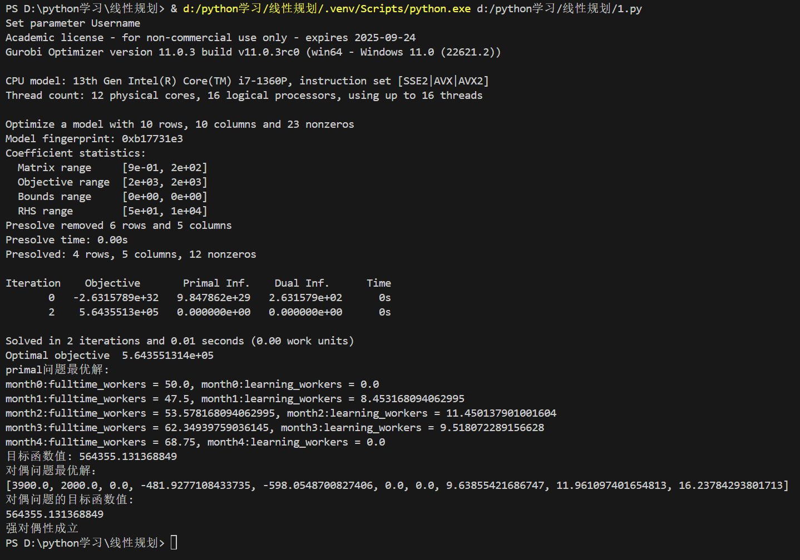
the output file:

(d)
Following the above code, the problem handling code is as follows:

# 更换april和may的对应b参数
constr_1=model.getConstrByName("April")
constr_2=model.getConstrByName("May")
model.setAttr(GRB.Attr.RHS,[constr_1],[9000])
model.setAttr(GRB.Attr.RHS,[constr_2],[10000])

model.optimize()

# 输出结果
if model.status == GRB.OPTIMAL:
print("修改后的问题最优解:")
for i in range(5):
print(f"month{i}:fulltime_workers = {x[i].x}, month{i}:learning_workers = {y[i].x}")
print(f"目标函数值: {model.objVal}")

else:
print("没有找到修改后问题的最优解.")

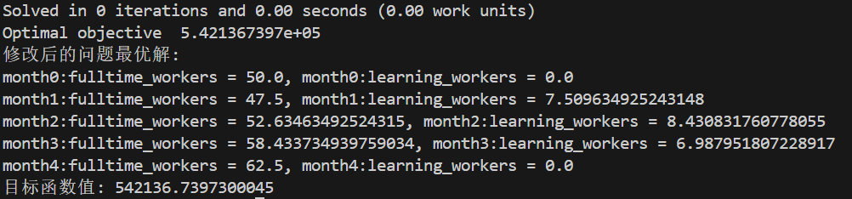
the output file:

